

NAME | CMS ID | CLASS | SECTION
AHMED RAZIULLAH | 366191 | BEE-13 | B
MUHAMMAD OMAIS | 390616 | BEE-13 | B
MUHAMMAD AMMAR | 332628 | BEE-13 | B

Project Report: Signal Conditioning Amplifier

1. Introduction:
The Amplifier Module is designed for amplification of small AC or DC signals from analog sensors, strain gauges, transducers, and similar devices. This project focuses on evaluating the module, identifying limitations, and proposing improvements to achieve optimum performance.

2. Module Overview:
The module incorporates the AD620A IC, a 7660 Voltage Converter IC, LM358 Op Amp, and supporting components. It operates in the voltage range of 3.5-10V, providing an adjustable gain of 1.5 to 1000x, adjustable offset, and a bandwidth of 120kHz (for gain = 100x).

3. Theory of Operation:
The power for the module is supplied through VIN (3.5-15V), generating both positive (V+) and negative (V-) power rails. The AD620's gain is adjusted via a 100K potentiometer, and the output passes through an LM358 configured as a unity gain buffer.

4. Limitations:
Negative Voltage Generation: The module's use of the 7660 charge pump introduces electrical noise, affecting performance. Additionally, the 7660 is susceptible to latch-up at high voltages.

5. Evaluation Results:
a. Ripple Reduction: To address ripple in the negative voltage output, adding bulk capacitance (10uF – 100uF) to V- significantly reduces output ripple.

b. Elimination of 7660: Removing the 7660 allows external negative voltage input, improving performance and enabling the use of a cleaner power source with a wider voltage range.

c. Potentiometer Replacement: Consider replacing the 100K potentiometer for gain adjustment with a smaller value (10K or 1K) for better linearity, especially at higher gains.

6. Project Modifications:
a. Negative Voltage Ripple Reduction: Add a bulk capacitor (e.g., 10uF) between V- and GND to minimize ripple.

b. Elimination of 7660: Optional removal of the 7660 for external negative voltage input, allowing the use of a cleaner power source.

c. Potentiometer Replacement: Optionally replace the 100K potentiometer with a smaller value for better linearity or use a fixed resistor for a specific gain.

Simulation

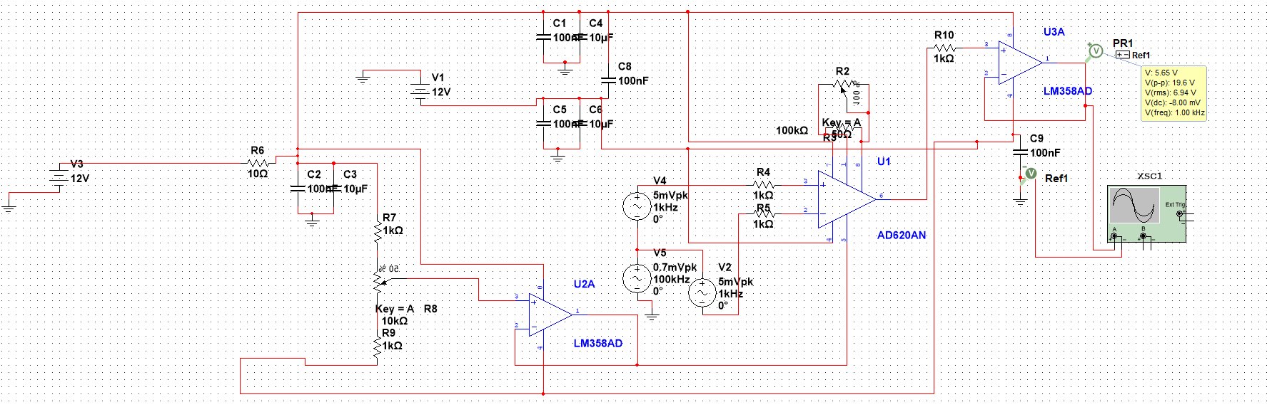
In the circuit diagram, the voltage input V5 is the high frequency noise signal, which gets cancelled out by the differential amplifier.

7. Scope Capture Results:
a. Improved Performance: Removal of the 7660 and implementing suggested modifications resulted in enhanced performance, as demonstrated in the scope capture with a 5mV 1kHz AC input.

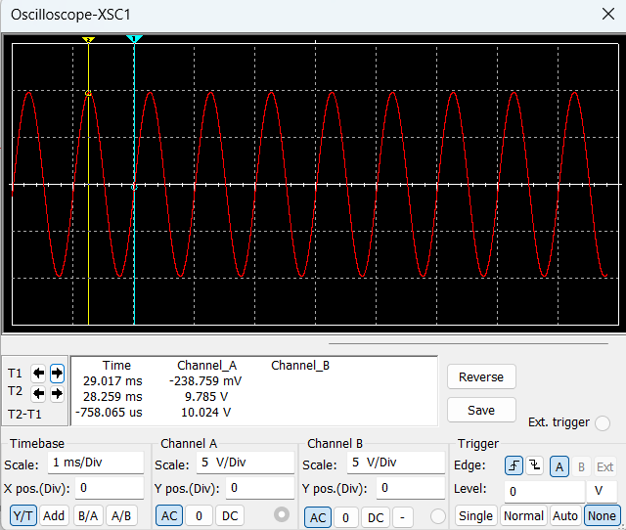

8. Recommendations:
a. Negative Voltage Supply: If possible, use an external, clean negative voltage supply instead of relying on the 7660 charge pump.

b. Gain Adjustment: Consider replacing the 100K potentiometer with a lower-value pot or fixed resistor for precise gain control.

9. Conclusion:
The project successfully optimized the Amplifier Module by addressing limitations and suggesting modifications. The elimination of the 7660 charge pump, ripple reduction, and potentiometer adjustments significantly improved the module's performance for applications requiring amplification of small signals.

10. Future Work:
a. Investigate alternative negative voltage supply solutions.

b. Explore different potentiometer options to improve gain adjustment precision.

c. Conduct further testing for different input signal characteristics.

This project report provides a comprehensive overview of the Amplifier Module, evaluates its performance, and offers practical modifications for enhanced

11. Application Areas

Sensor Signal Conditioning:
Amplification of signals from sensors such as temperature sensors, pressure sensors, and photodetectors.

Strain Gauge Amplification:
Used to amplify signals from strain gauges in applications like load cells and force sensors.

Biomedical Instrumentation:
Signal conditioning for bioelectric sensors, ECG (Electrocardiography), and EEG (Electroencephalography) devices.

Transducer Amplification:
Amplifying signals from transducers, converting physical quantities into electrical signals.

Bridge Sensor Amplification:
Amplifying signals from Wheatstone bridge sensors for applications like weight measurement.

Low-Frequency Signal Amplification:
Suitable for applications where low-frequency signals need amplification with high precision.

Data Acquisition Systems:
Integration into data acquisition systems for precise measurement of small signals.

Instrumentation and Control Systems:
Used in instrumentation and control applications where accurate signal processing and amplification are critical.

Audio Signal Processing:
Amplification and conditioning of low-level audio signals, especially in audio recording and processing equipment.

Precision Instrumentation:
Integration into systems requiring high precision and low noise in signal processing.

Research and Development:
Utilized in laboratories and research environments for amplifying signals in experimental setups.

Industrial Automation:
Signal conditioning in industrial automation systems for monitoring and control.

Environmental Monitoring:
Signal amplification for sensors used in environmental monitoring applications.

Automotive Sensors:
Amplification of signals from various automotive sensors for applications such as engine control systems.

